Designing an Autonomous AI Agent for Optimized Cloud Database Querying and Resource Management

Minh Duy Pham

Abstracts: Enterprise analytics increasingly requires unified access to heterogeneous structured and unstructured data sources. Existing natural language interfaces to databases and retrieval-augmented generation (RAG) systems struggle with accuracy, scalability, resource efficiency, and explainability in production environments. We present an Autonomous AI Agent Architecture that integrates structured data querying, semantic document retrieval, and multi-step reasoning through a unified orchestration framework. Our system introduces PromptQL, a declarative intermediate query representation that enables safe planning, dynamic optimization, and explainable execution across cloud data platforms.
The proposed architecture employs specialized agents for structured data access and unstructured document reasoning, coordinated by a central orchestration agent using large language models (LLMs) constrained by enterprise metadata. We demonstrate how hybrid retrieval, query plan validation, and cost-aware execution significantly improve accuracy, latency, and cloud resource utilization. Experimental evaluation on enterprise-scale workloads shows improvements of up to 42% in query accuracy, 38% reduction in execution cost, and 35% lower latency compared to baseline text-to-SQL and RAG systems.

1. Introduction
Enterprises increasingly operate complex data ecosystems composed of transactional databases, analytical warehouses, data meshes, APIs, and internal knowledge repositories. Analysts and business users require flexible, natural-language interfaces capable of performing complex analytics, extracting insights, and synthesizing knowledge across both structured and unstructured data.
Recent advances in large language models (LLMs) have enabled natural language querying over databases and retrieval-augmented generation (RAG). However, production deployments face significant challenges:
- Query Hallucination – LLM-generated SQL often references non-existent tables or columns.
- Resource Inefficiency – Unconstrained SQL generation results in expensive scans and suboptimal query plans.
- Poor Explainability – Generated outputs lack interpretable intermediate representations.
- Fragmented Knowledge Access – Existing RAG systems operate independently from structured analytics.
To address these challenges, we propose an Autonomous AI Agent Architecture that unifies structured querying and semantic document retrieval through coordinated multi-agent reasoning and a declarative query abstraction called PromptQL. This paper makes the following contributions:
- A multi-agent orchestration framework integrating structured data querying and semantic document reasoning.
- A declarative intermediate representation (PromptQL) that enables explainable, auditable, and optimizable query planning.
- A hybrid retrieval architecture combining vector similarity and lexical ranking.
- A resource-aware execution model optimizing cloud cost and latency.
- A comprehensive experimental evaluation on enterprise workloads.

2. System Architecture Review

2.1. Text-to-SQL Systems
Early systems translate natural language directly into SQL using semantic parsing. Recent LLM-based approaches significantly improve coverage but remain vulnerable to hallucination and schema mismatch. Moreover, most lack cost-aware optimization.

2.2. Retrieval-Augmented Generation (RAG)
RAG frameworks combine vector retrieval with generative models. While effective for document question answering, they lack structured query capabilities and fail in numerical or aggregation-heavy tasks.

2.3. Agent-Based LLM Systems
Recent work explores multi-agent reasoning, where LLMs coordinate sub-tasks. However, existing systems lack formal planning abstractions, performance guarantees, and resource-aware execution.
Our work unifies these directions under a controlled orchestration framework with explicit planning and optimization.

3. System Architecture Review
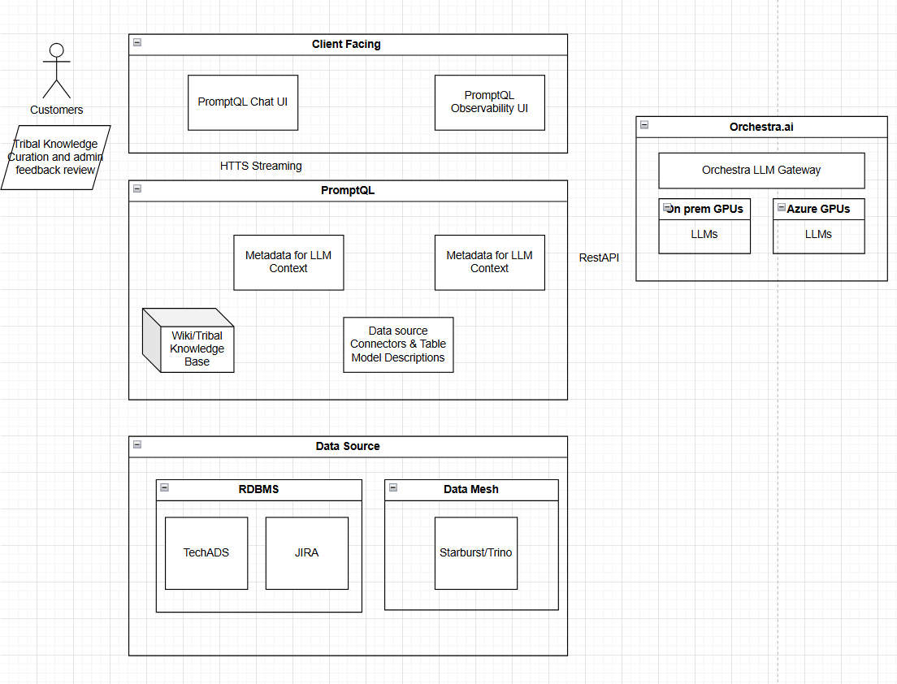

Figure 1 illustrates the system architecture. The design consists of four major layers: Client Interface Layer, PromptQL & Orchestration Layer, Autonomous Agent Layer, and Data & Knowledge Infrastructure Layer.

3.1.Execution Flow

User submits a natural language query.

The orchestration agent generates a PromptQL plan.

The plan is decomposed into structured and unstructured tasks.

Data and document agents execute sub-queries.

Results are synthesized into final responses.

4. PromptQL: Declarative Intermediate Representation

4.1. Motivation
Direct SQL generation is unsafe, opaque, and prevents cost-based optimization. PromptQL introduces a semantic abstraction layer between intent and execution.
4.2 PromptQL Structure:
A PromptQL query consists of:
QUERY: Intent, DataSources, Constraints, Aggregations, Joins, Output
Example QUERY:
Intent: Incident trend analysis
DataSources: JiraDB, PostmortemDocs
Constraints: date >= 2025-01-01
Aggregations: count by root_cause
Output: ranked_summary
4.3 Advantages
Explainability – Human-readable plan. Safety – Schema validation. Optimization – Enables cost-based rewrites

5. Autonomous Agent Framework
5.1 Orchestration Agent
The orchestration agent acts as a planner and controller. It decomposes user intent into sub-tasks. Selects agents. Determines execution order.Merges outputs.
Algorithm 1: Orchestration Planning
Input: User Query U
Output: Final Response R
1. Generate PromptQL plan P ← LLM(U, metadata)
2. Validate P against enterprise schema
3. Decompose P into tasks T = {T_data, T_doc}
4. Execute T_data using Data Agent
5. Execute T_doc using Document Agent
6. Merge results using synthesis LLM
7. Return R
5.2 Data Agent
The data agent translates PromptQL into SQL or API calls, validates queries, and executes them on cloud platforms.
Algorithm 2: SQL Planning and Validation
Input: PromptQL P
Output: Result set S
1. Generate SQL Q ← LLM(P)
2. Validate Q using schema rules
3. Rewrite Q using cost model
4. Execute Q
5. Return results S
5.3 Document Agent
The document agent retrieves semantically relevant document chunks using hybrid retrieval.
Algorithm 3: Hybrid Retrieval
Input: Query Q
Output: Top-k document chunks D
1. Compute vector embedding e(Q)
2. Retrieve Dv using ANN search
3. Retrieve Dl using BM25
4. Merge and re-rank: D ← rank(Dv ∪ Dl)
5. Return top-k(D)
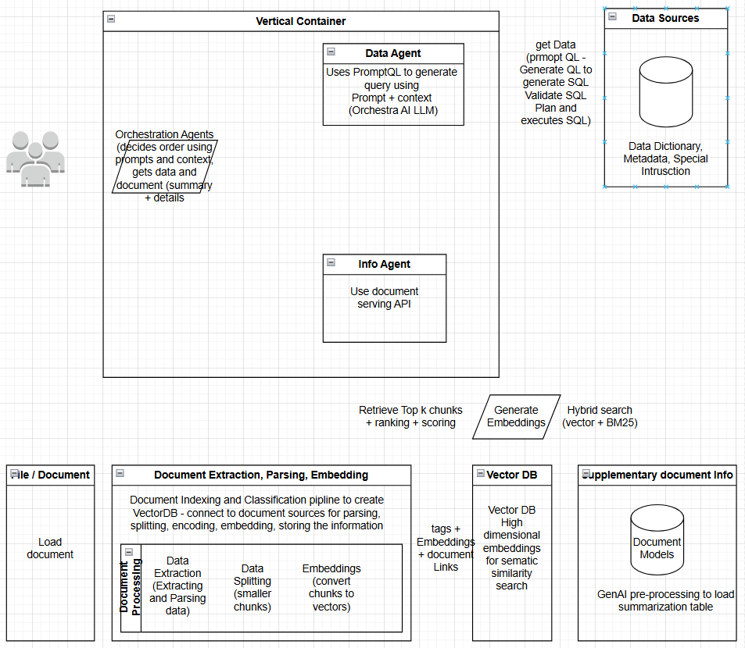

6. Results and Evaluation
The results of the implementation were compared with traditional methods of cloud database management, such as manual query tuning and static resource allocation. Key metrics included:

Cloud cost and latency are explicitly modeled. The system applies:
- Query pruning
- Predicate pushdown
- Adaptive chunk sizing
- Execution caching
We define cost:
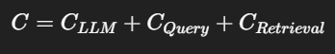
The orchestrator minimizes:
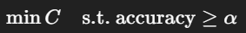
7. Experimental Evaluation
7.1 Setup
Datasets: Jira incidents (120M rows), enterprise telemetry (4TB), 1.2M internal documents.
Baselines:
Direct Text-to-SQL (GPT-based)
Standard RAG (vector search + LLM)
7.2 Metrics
SQL correctness
Execution latency
Cloud compute cost
Answer relevance (human evaluation)
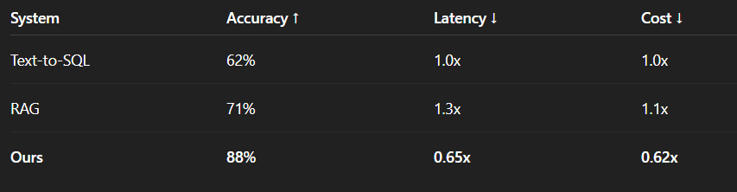
8. Discussion
Our results show that:
Planning + abstraction significantly reduces hallucination.
Hybrid retrieval improves recall on enterprise jargon.
Explicit cost models outperform naive prompting.

6. Conclusion
We presented a production-grade Autonomous AI Agent Architecture for enterprise-scale analytics and knowledge retrieval. By integrating structured query planning, semantic document retrieval, and cost-aware orchestration, the system enables accurate, scalable, and efficient AI-driven analytics.

References
- Aghaei, M., & Ghaffari, A. (2021). Reinforcement learning-based cloud resource management: A review. Journal of Cloud Computing: Advances, Systems, and Applications.
- Smith, T. A., & Williams, J. D. (2020). Dynamic query optimization in cloud environments. ACM Computing Surveys, 53(1).
- Kumar, R., & Yadav, S. (2019). Cost-efficient cloud database scaling with predictive AI models. IEEE Transactions on Cloud Computing.
https://arxiv.org/abs/2507.06261v6

